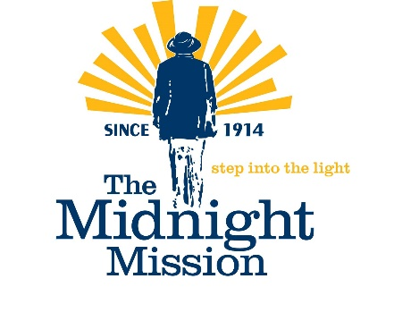

FOR IMMEDIATE RELEASE Contact: Georgia Hawley
ghawley@midnightmission.org
310-383-1795

LAUGHTER WITH A MISSION - HEALING THROUGH LAUGHTER SINCE 2012

WHAT: Laughter With A Mission (LWAM) – OPEN MIC

WHEN: Thursday – July 2, 2026 - 2:30 pm to 4:00 pm (Sign-ups begin at 2:00 pm)

WHERE: The Midnight Mission, 601 S. San Pedro St., LA, CA 90014 – Guest Dining Room

WHO: Our guest emcee is stand-up comedian Lindsey Crowley, who has performed at the Laugh Factory, the Comedy Store, and venues throughout Southern California. She is excited to return to The Midnight Mission, where she last performed nearly seven years ago. It's also the first invitation she's received to come back, which she is choosing to interpret as "worth the wait." Lindsey believes humor has the power to bring people together and make even the toughest days a little lighter.

Guests from our homeless community, community partners, and The Midnight Mission's program participants and staff will showcase their talents. The Laughter With A Mission Open Mic will feature up to 15 performances, each lasting three to five minutes, along with special guest appearances. Performance slots will be available on a first-come, first-served basis.

WHY: Laughter With A Mission creates opportunities for people from all walks of life to connect through humor, storytelling, creativity, and self-expression. By sharing the stage, participants build confidence, foster community, and discover common ground. Whether performing or simply enjoying the show, guests experience the healing power of laughter and the joy that comes from being seen, heard, and celebrated. The Midnight Mission believes arts and entertainment are to the soul what food is to the body.

HOW: All are welcome, and there is no charge.

About The Midnight Mission: Founded in 1914, The Midnight Mission offers paths to self-sufficiency to individuals and
families experiencing homelessness and poverty. Through emergency services, 12-step recovery programs, family housing,
education, job training, and workforce development, The Midnight Mission provides a compassionate bridge to lasting
stability and self-reliance. By removing barriers and providing accountability, structure, and support, The Midnight Mission
helps people rebuild their lives and become productive members of their communities. Our conviction and commitment to
their success define who we are. For more information, please visit www.midnightmission.org.

